Web App:

Services used:

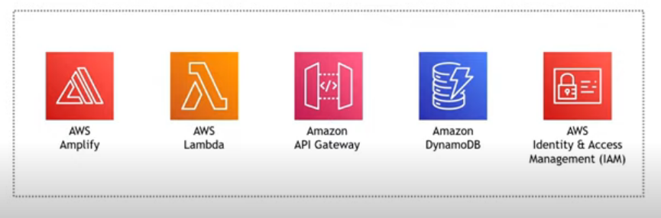

What do we need ?

* A way to create/host a webpage
* A way to invoke the math functionality.
* A way to do the some math.
* Somewhere to store the result of math.
* A way to handle the permissions.

A way to create/host a web page 🡪 AWS Amplify : used to build and host a website. And we will use text editor to create a index.html file in my local machine.

Search for AWS Ampilfy. Click on Get started

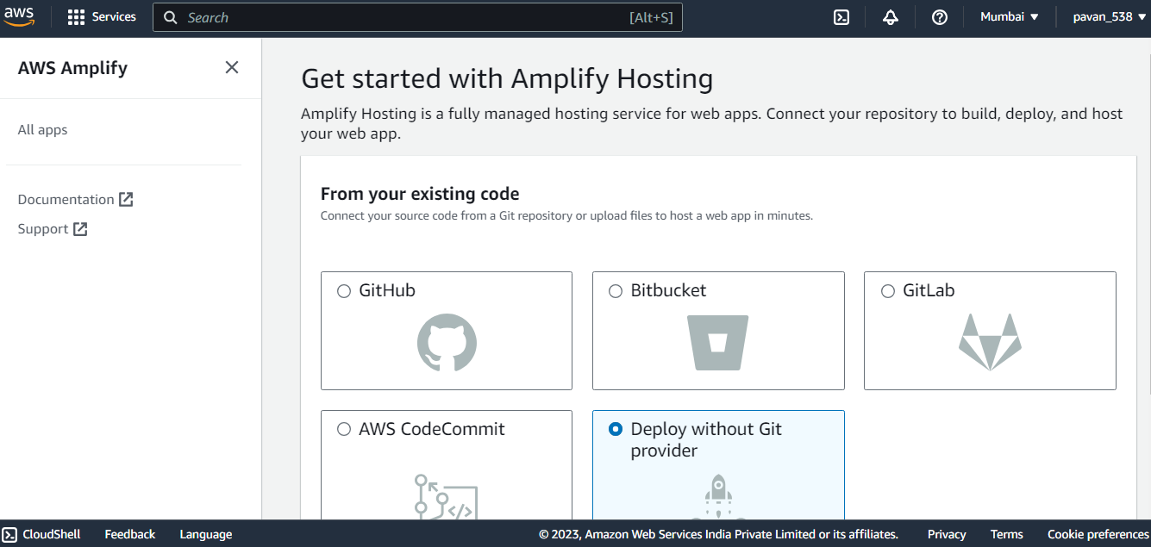

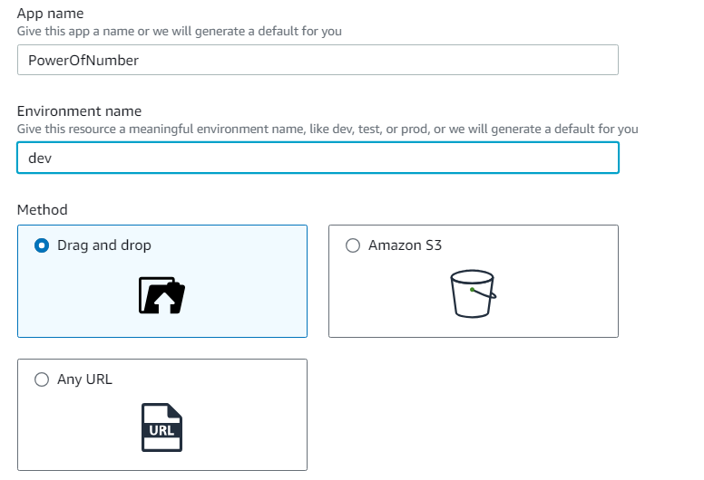

Step 2:

To do math 🡪 AWS Lambda : a bit code code that runs when we trigger(serverlessly)

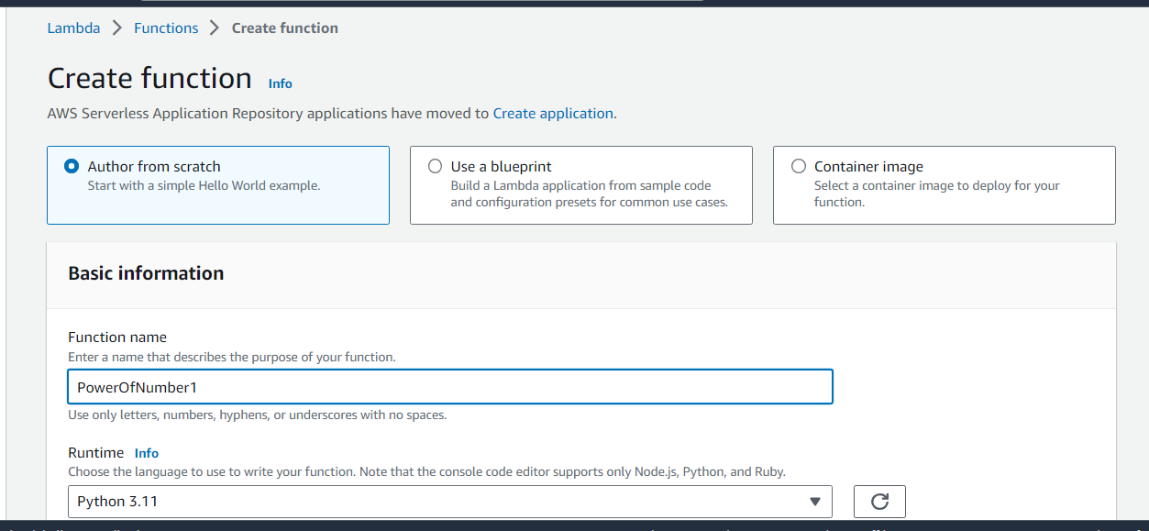

Lambda function with source code of power of numbers

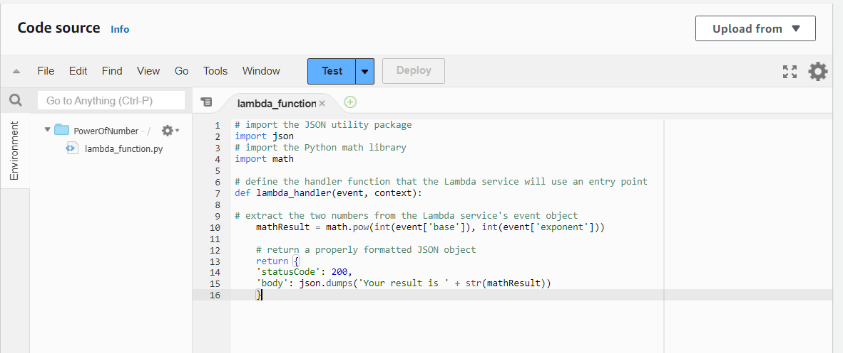

Click on ctrl + s, then deploy.

Now, test it

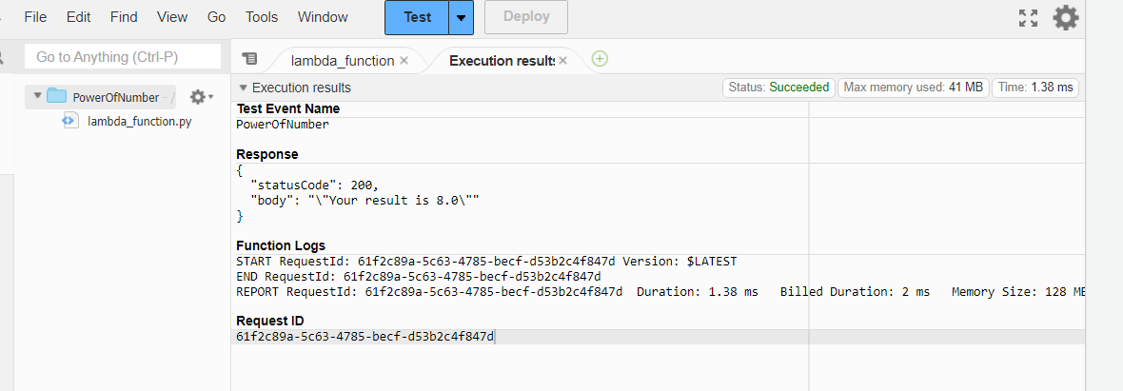

Now, we need to do that to invoke the math functionality(invoke lambda function) 🡪 Aws API Gateway 🡪 core services which helps to build our own API(http, REST, Socket).

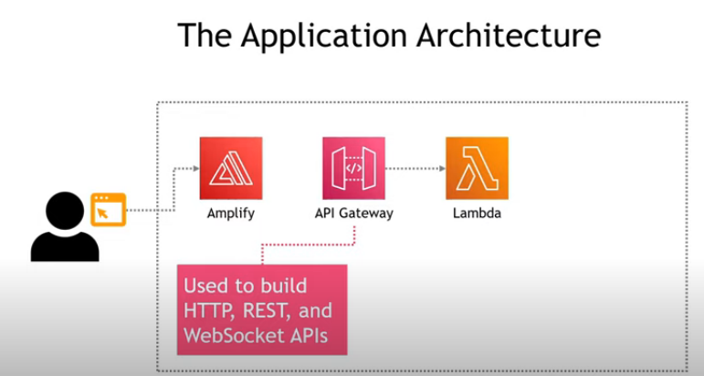

STEP 3: Open AWS API Gateway and build REST API

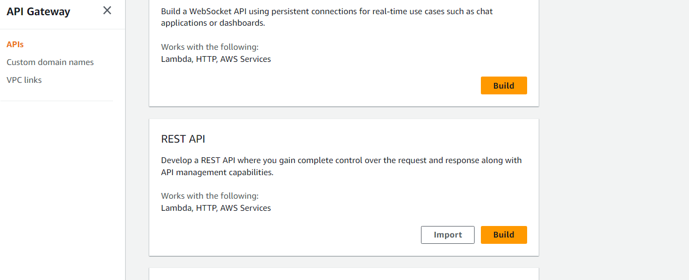

Click on create API

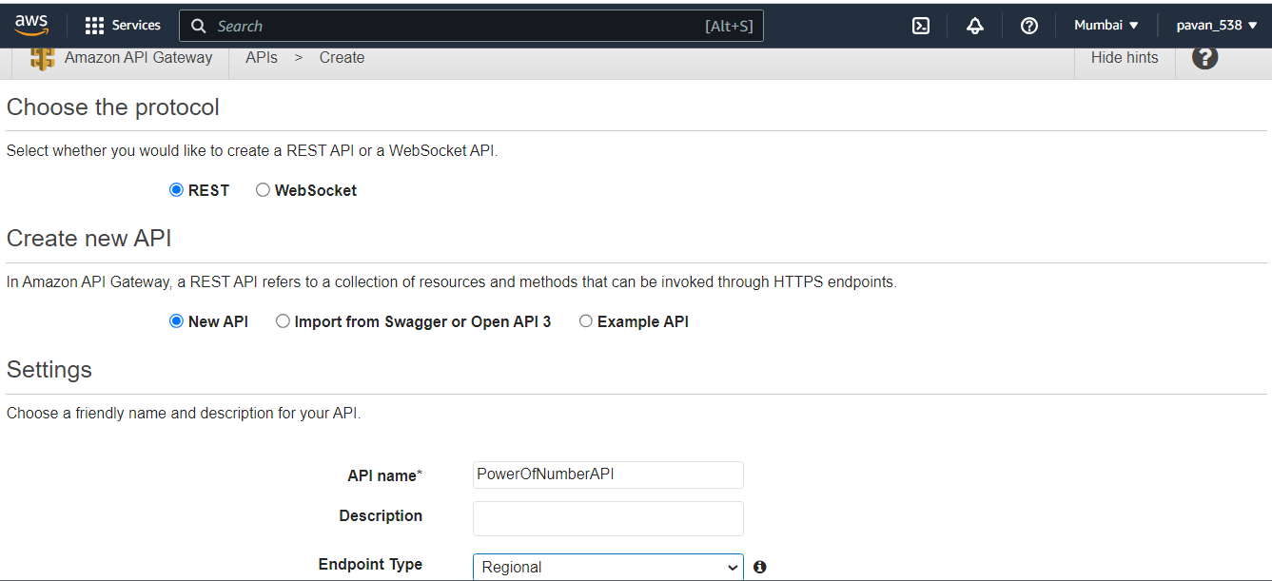

Now create a method called POST(user is sending data for two numbers)

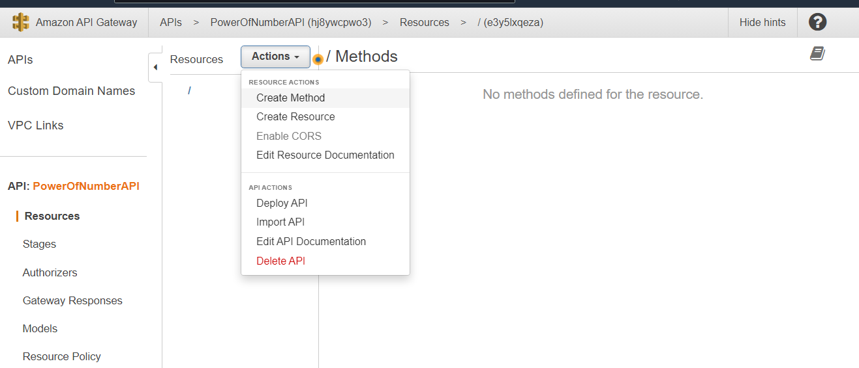

Click on tick mark

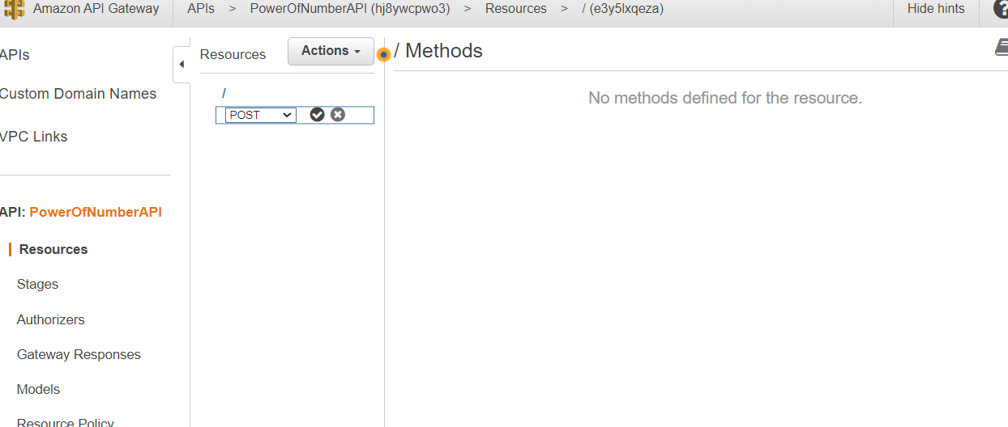

Integration type is lambda function

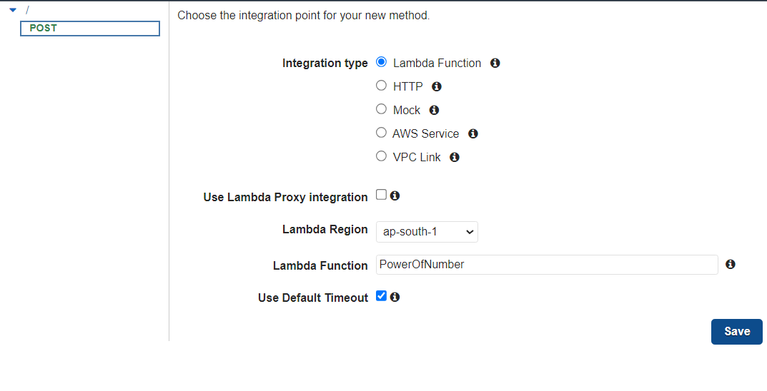

Click on save. Here, we are giving permission to API Gateway permission to invoke your Lambda function.

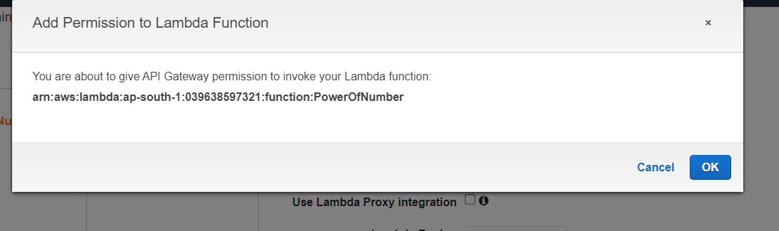

Flow of integration:

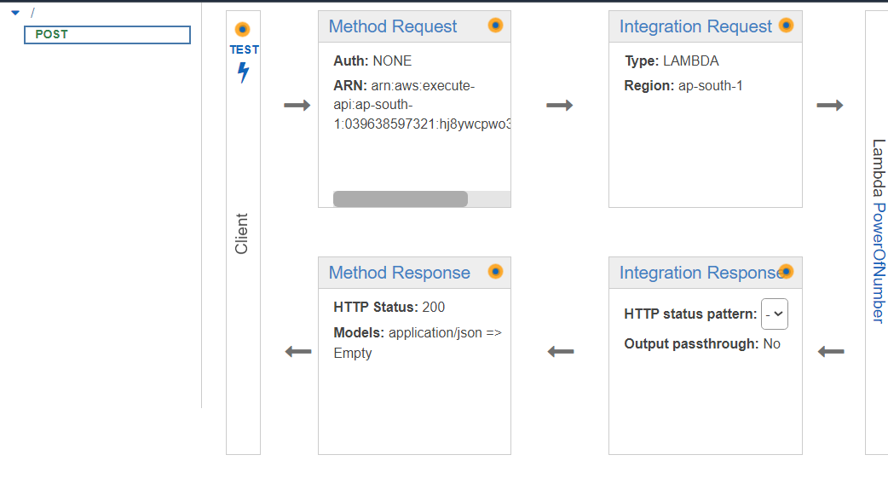

One more thing, we need to do is that Enable CORES()🡪 basically, it does to allows web app running in one origin or domain able to access resources on different origin or domain. My application running on one domain called amplify and other domain called lambda function.

Click on post(actions) 🡪 click Enable

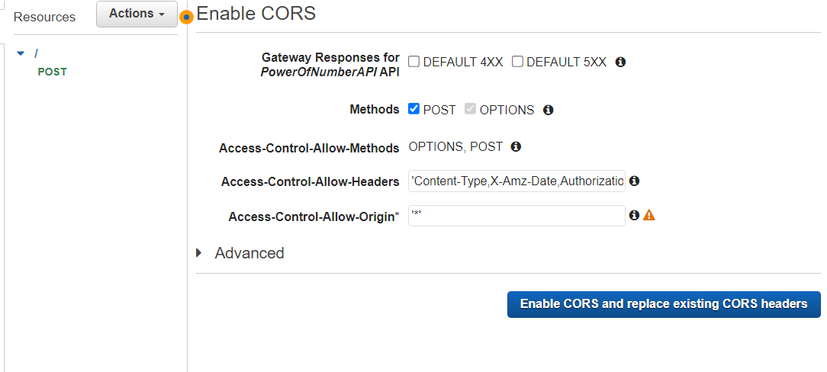

Now, let us deploy it out. Go to actions

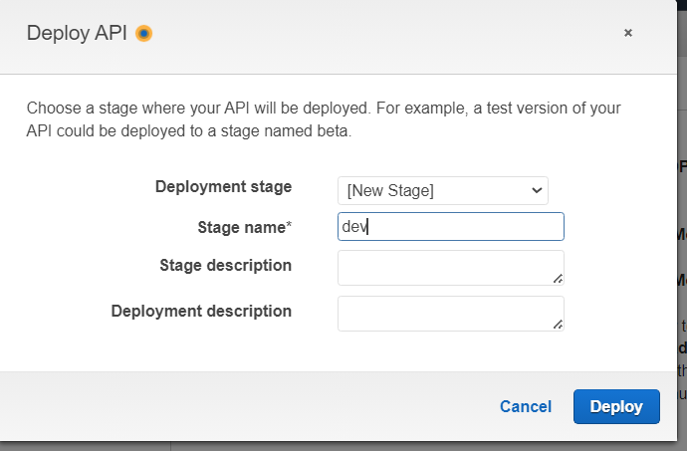

API Gateway URL: <https://hj8ywcpwo3.execute-api.ap-south-1.amazonaws.com/dev>

Now, test it out. Go to resources then POST then resources body.

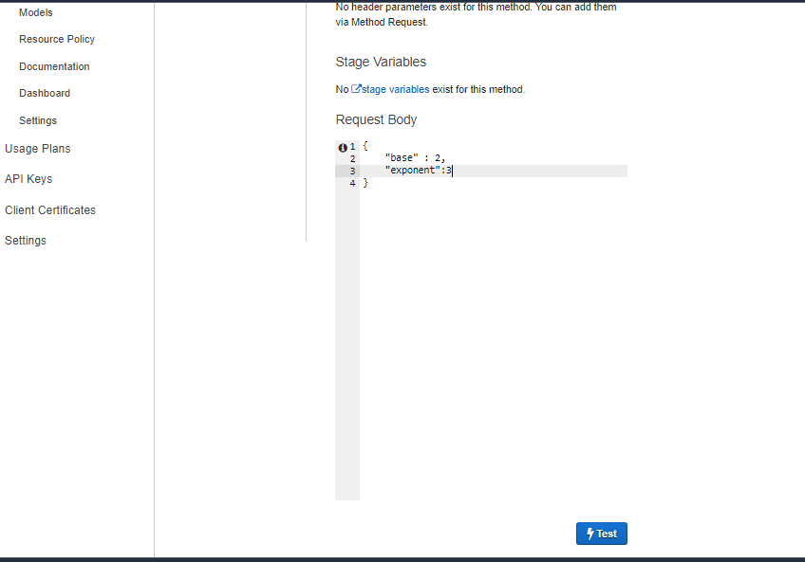

Result:

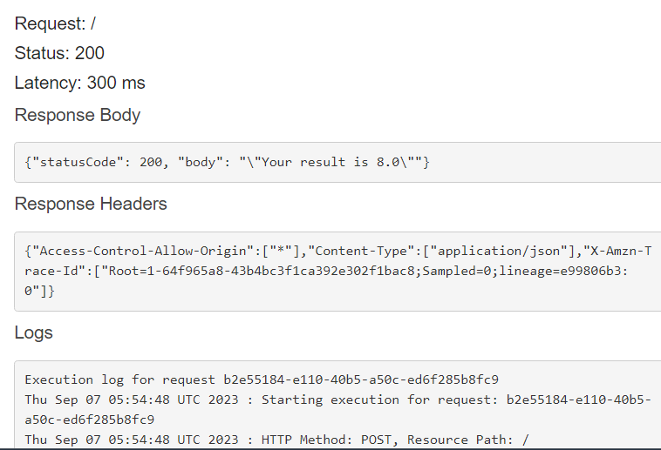

STEP 4: To store the result at database

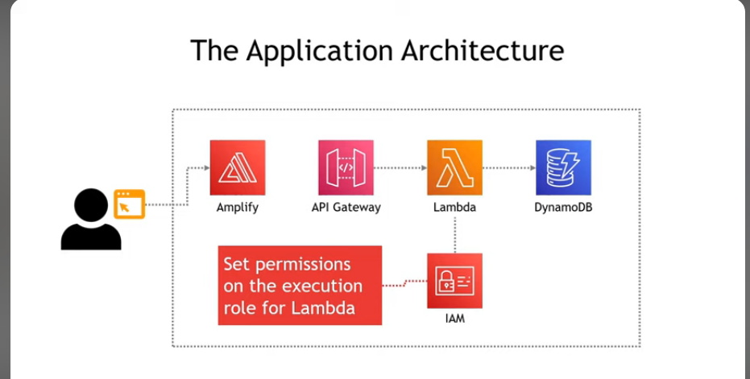

We are using dynamoDB which is NoSQL database.It is lighter than Relation Database. We need to setup schema etc.

Use IAM 🡪 we need to give our lambda function permission to write to a database.

Now, Create a DynamoDB Table :

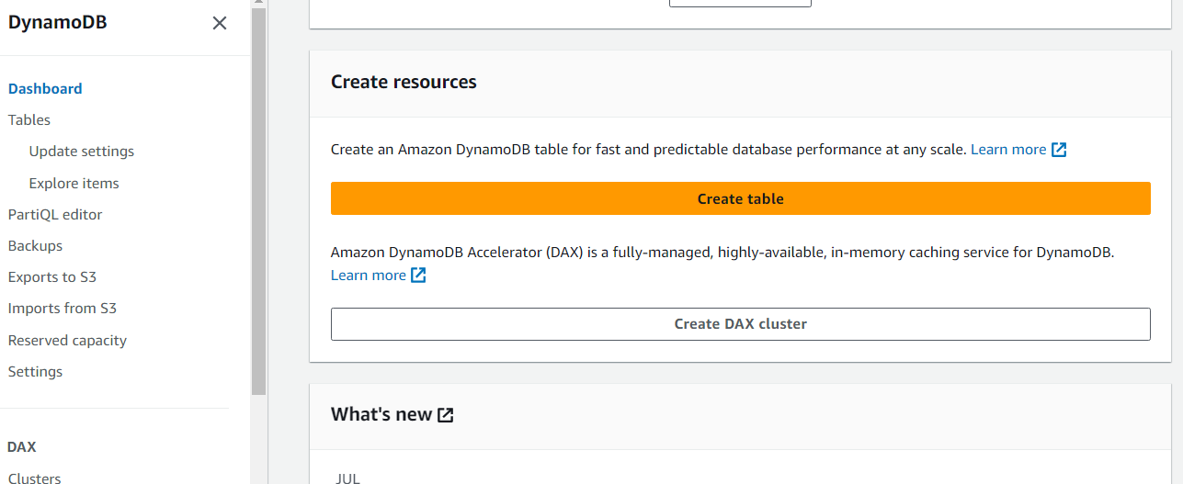

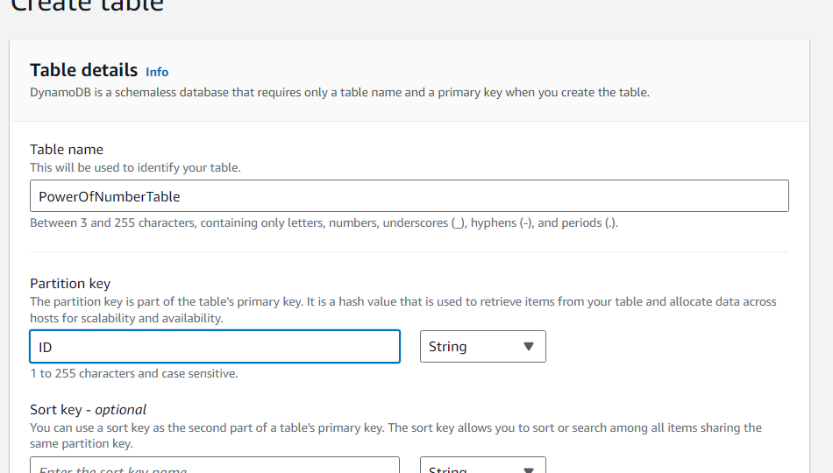

Save the ARN : arn:aws:dynamodb:ap-south-1:039638597321:table/PowerOfNumberTable

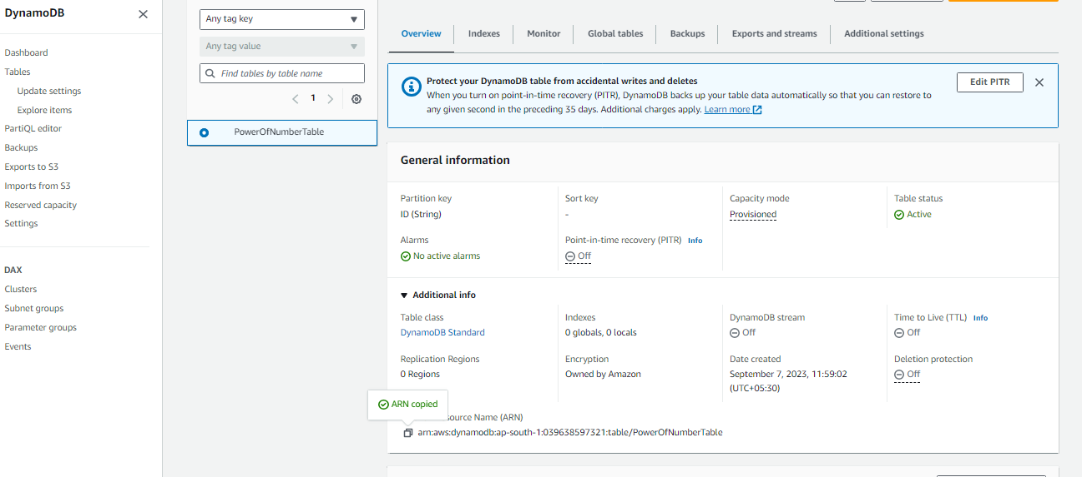

Now, we are going to give lambda function permissions.

Go to lambda function >> configuration >> permissions >> execute role(give permissions using IAM Role or open in new tab )

Now create inline policy >> add ARN(which gives permission to lambda function)

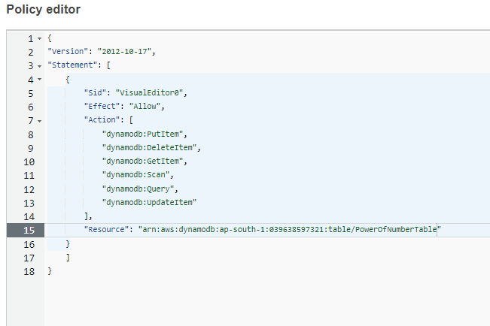

Create policy:

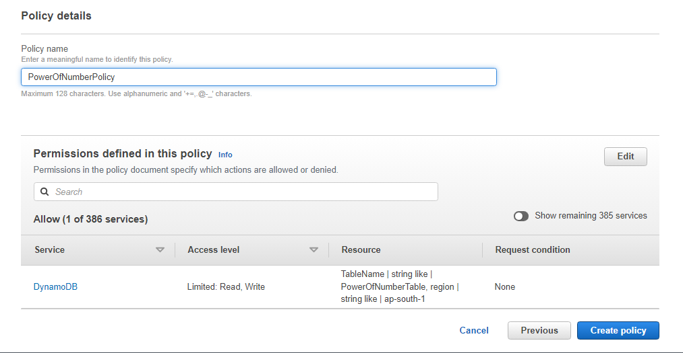

UPDATE the lambda function

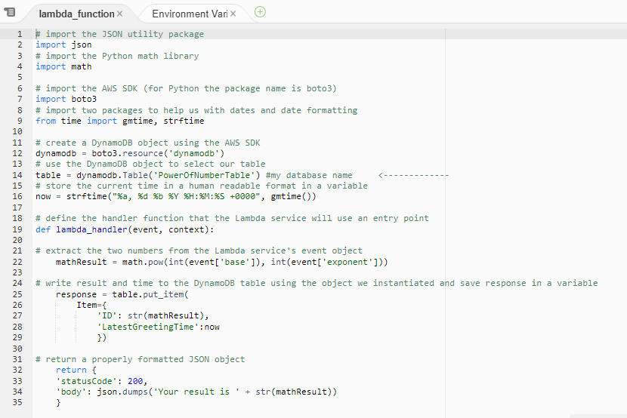

Result:

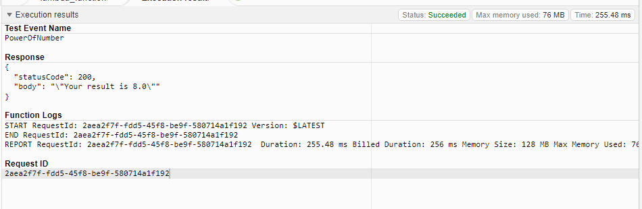

Now, go to dynamoDB >> Explore table

Result was stored in dynamo DB

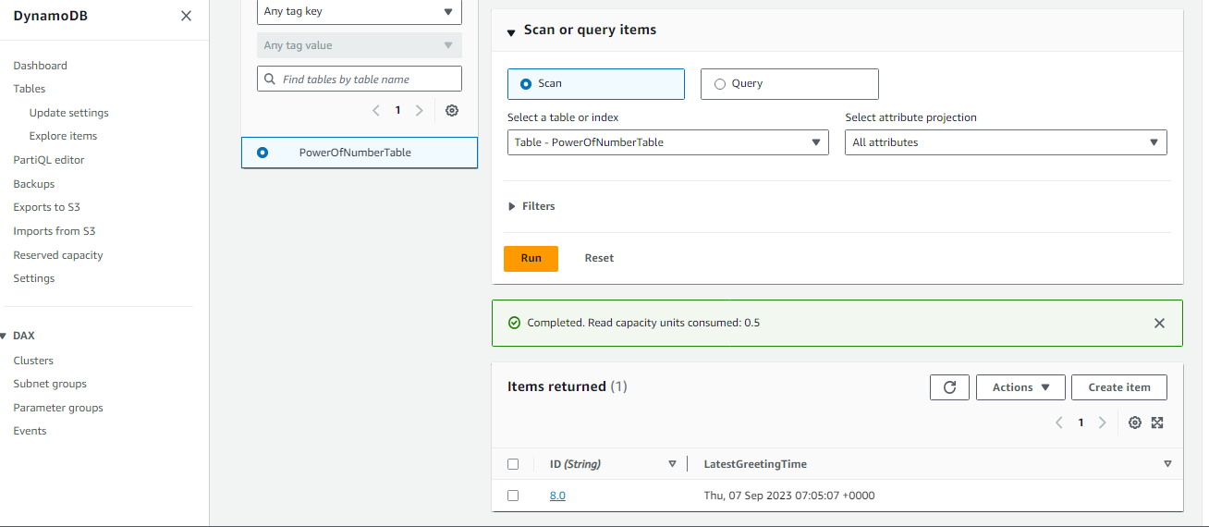

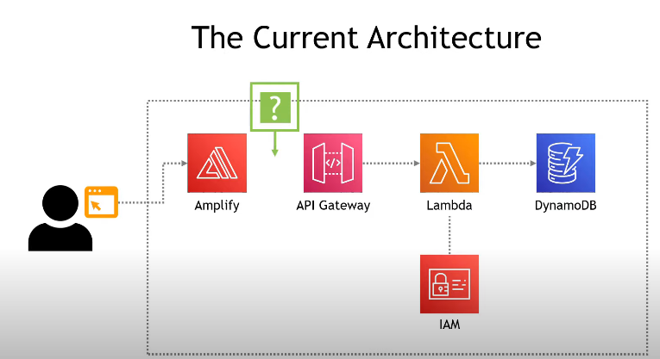

STEP 5: Update the index.html(link the API URL)and deploy in the ampilfy

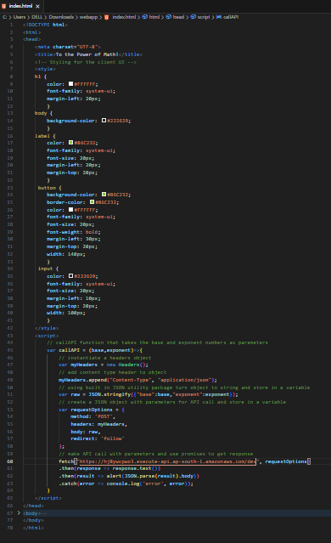

After deployment:

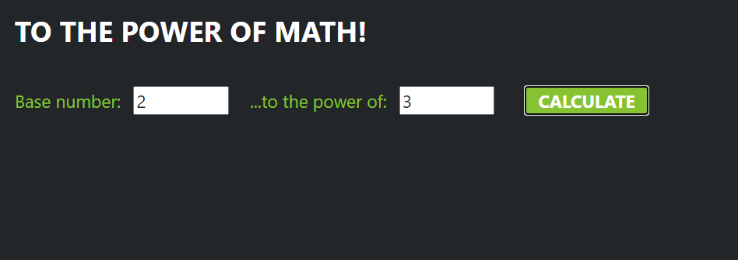

Result:

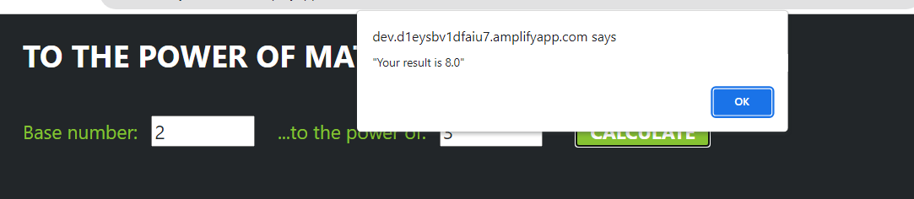

Link : https://dev.d1eysbv1dfaiu7.amplifyapp.com/